Little Birch Parish council
Ward member report, May 2016
Surgery
On 03.05.16 I held a ‘surgery’ at Much Birch village hall to honour a promise I made when campaigning for election 12 months ago. Whilst canvassing several residents commented that they only ever saw politicians at election time and I promised to hold a surgery this May (in addition to attending parish council meetings etc.) I will give a verbal report at the Little Birch parish council meeting of any relevant issues.

Education
With regard to the recent budget announcements and the publication of the ‘Educational Excellence Everywhere’ White Paper, I would like to touch upon the steps the council is now taking, including consideration of the current consultation about the schools national funding formula. Given the content of the White Paper and its proposals, these have the potential to radically alter the education system in Herefordshire (including Much Birch).
Firstly, we are pleased that the funding formula consultation may result in additional funding for education in Herefordshire. We have been lobbying national government for some years about the current unfairness in the funding arrangements, and it is pleasing to see some indications that this may improve.
The contents of the White Paper will be considered and debated at council level and there will be full engagement with schools and academies about this. We will be meeting with the two county MPs to ensure they are fully aware of the implications of the consultation for Herefordshire residents, in the light of the council’s initiatives in the education strategy and particularly the schools capital investment strategy.
Whatever the outcome of the White paper which reinforces the council’s responsibility towards children, we will ensure that our commitment towards improving the education, health, care and economic outcomes of our young people remains central to everything we do.

Hereford Bypass
The original draft proposals looked at a potential corridor for the Hereford Relief road from the A49 in the south, going west of the city to the A49 in the north, and consideration to continue to the A4103 Worcester road. This corridor is subject to route selection in phases in conjunction with all statutory partners.
The first phase is the South Wye link from the A49 south to the A465 Abergavenny road, which should be subject to a planning application in March 16. Over the last couple of months and following the first planning consultation, some additional work has been required to deal with issues raised by a statutory consultee. Having satisfied these concerns a further consultation period will follow ahead of the planning application coming to Planning committee.
The route selection went through a comprehensive process and consultation which enabled a successful bid for funding to build the road and do some additional sustainable travel options in and around Belmont. Subject to normal processes and procedures, phase 1 of the relief road (South Wye Link) will begin once planning is approved.
The process for the further sections of the HRR are in place and a considerable amount of work will be required for route selection within the corridor, archaeology and preparation of plans for consultation and adoption, and ensuring all funding opportunities through the many channels open to us, are pursued.
It must be stressed that Herefordshire has adopted the Core Strategy after years of consultation. The Western Relief Road is adopted as part of that strategy because it opens up the infrastructure to allow the strategic housing sites to be built out and sends a message to business that Herefordshire Council will support business growth by having infrastructure in place to get in, out and around Hereford.
To support our priorities of adult and children wellbeing and economic growth, this county must invest in the minimum requirement of a bypass for the city to unlock the potential for housing and business opportunity to raise our income level to support the priorities.
Map shows proposed corridor for Hereford bypass & areas for housing growth.
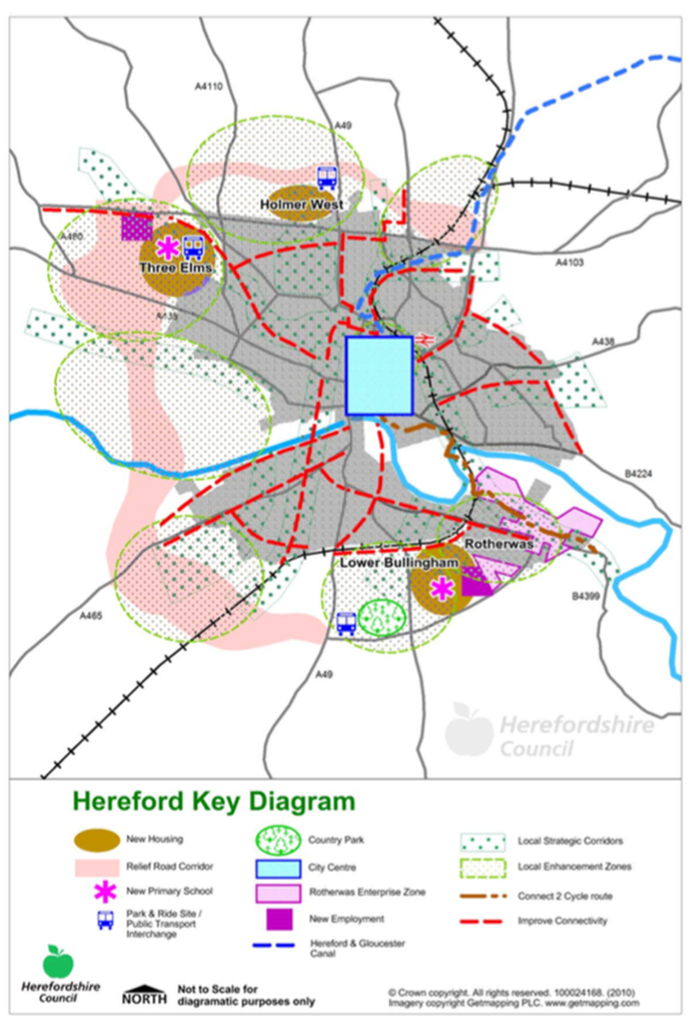

Marches businesses invited to apply for a share of over £11m of European funding

Organisations across the Marches are being invited to apply for a share of more than £11 million of European funding for schemes which will provide support to businesses.
Applications are being invited for projects focused on research and innovation, business competitiveness, the low carbon economy and environment and resource efficiency.
The four themes have been identified as priorities for funding in the Marches European Structural and Investment Strategy.
The funding is part of the Marches LEP region’s total allocation of around £92m and the maximum available for each priority area in this round of funding are:
- SME Support and Competitiveness - £3.5 million
- Research and Innovation - £4 million
- Environment and Resource Efficiency - £1,725,490
- Low Carbon - £2 million
The deadline for each funding call is May 27 2016 and the minimum application amount is £500,000. Projects will be delivered between now and 2020.

World War 1
Herefordshire First World War Centenary Committee and Herefordshire Council are holding an open day called 'the family at war’ to give people the opportunity to come up with ideas of events and activities that could take place in Herefordshire to commemorate the incredible contribution to the war effort of 'ordinary' people in 2017.
The event is being held at the Herefordshire Archive and Records Centre on May 7 between 10am and 4pm (Fir Tree Lane, Rotherwas) and we invite community groups, schools, uniform clubs and anyone with an interest in commemorating the centenary to join us and help. Further information can also be found on www.herefordshire.gov.uk/fwwc

